StratML Tagging with Microsoft Word Quick Start Guide
Editor(s): Ictect, Inc.
Contributing Authors: Pradeep Jain and Vivian Dey
Last Updated: September 23, 2009
Status: Draft

Overview
This guide provides the basic information for tagging Strategy documents with Microsoft® Word 2007. It also provides an example of tagging a strategy document with StratML schema.
Please note that Microsoft Word Professional or Enterprise version is required. Other versions of Word do not support XML with custom schemas.
In general, the steps for tagging strategy documents with Microsoft Word are:
- Attach StratML Schema to the document
- Apply XML tags and attributes
- Save the document as XML
The steps are as described below.

Attach StratML Schema to the document

- Download the StratML schema from the official site (currently http://xml.gov/stratml/draft/StrategicPlan.xsd) and place it in a local folder (such as C:\StratML\StrategicPlan.xsd).
- Open the strategy document to be tagged with StratML in Word 2007.
Go to the Developer tab in the ribbon at the top:

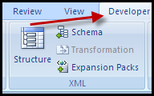

NOTE: If your system does not show the Developer tab (as shown in the illustration below), follow the steps given below:
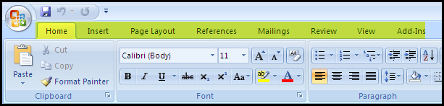
- Click on the Office Button in Microsoft Word.

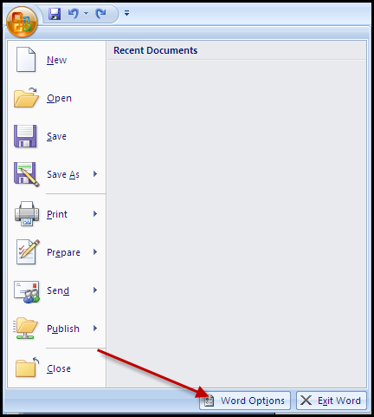

- Go to Word Options tab at the bottom and click on Show Developer tab in the Ribbon and press OK.
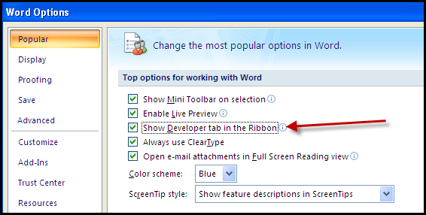
- When the Developer tab shows up, click on it. Click on the button “Schema”.
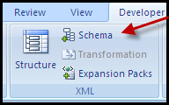

- This opens a dialog box Templates and Add-ins.
- Click on Add Schema button in the dialog box.
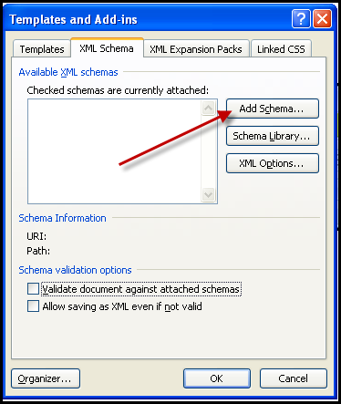

- A Window opens up that asks you to give the location of the schema.
- Click on Open and click on OK in the dialog box that opens. Browse to the location where the schema is placed (C:\StratML\StrategicPlan.xsd).
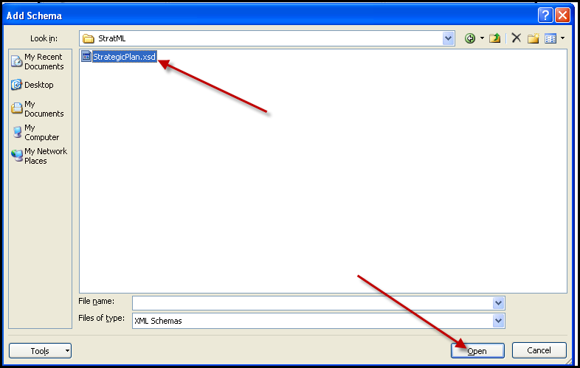
- Select the Schema and click OK.

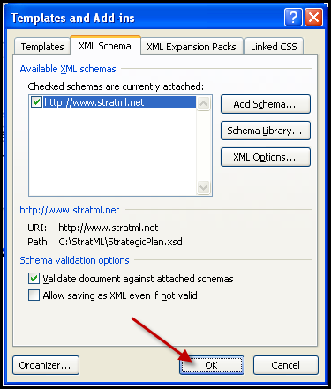

Word will show the XML Structure panel. The document can now be tagged with StratML elements.
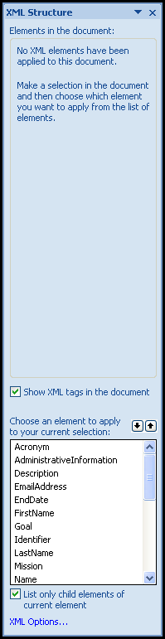

Tagging the Document

- Select the complete text of the document and click on “StrategicPlan” from the bottom portion of the “XML Structure” panel.
- Word shows the following dialog box. Click on Apply to Entire Document.
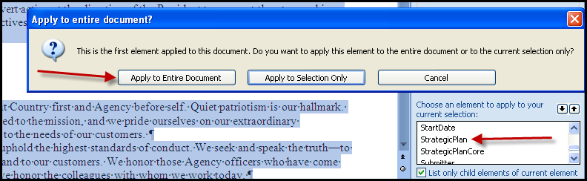
- For tagging specific elements, such as Name, select the text to be tagged. Right click and select “Apply XML Element”, as shown below. The selected element will be applied to the selected text.
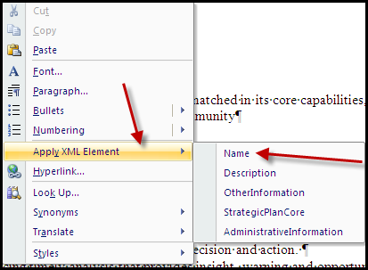

- Please note that during the tagging process, a squiggly would show up in the left border of the text of the document from the beginning till the end. This is due to the fact that the document is invalid while being tagged.
- Continue tagging one element at a time by selecting these, and on right-clicking, apply different XML tags, such as Name or Identifier or Description as required on all items till the end of the document.

Saving the File as XML

- To save the tagged file, go to Word Office button and click on Save As.
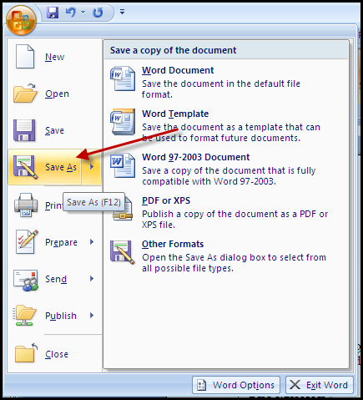

- Select the “Save as type” to be “Word 2003 XML Document”. Check “Save data only.”

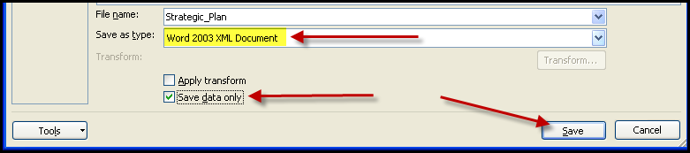

- Word will prompt with a message that the file cannot be saved as it is invalid.

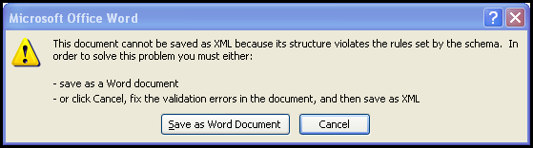

- To allow saving the document even if the XML is not valid:
- First, click on XML Options in XML Structure on the right-hand panel.
- A dialog box opens up that has a check box for Allow saving as XML even if not valid option.
- Click in the check box and press OK.
- Now save the file.
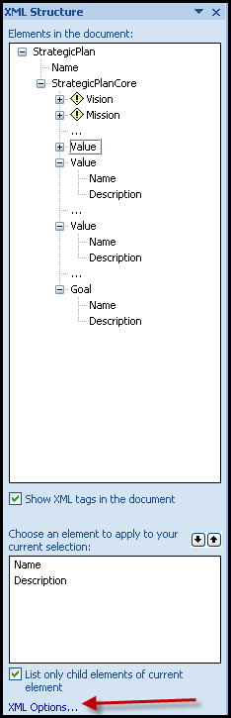
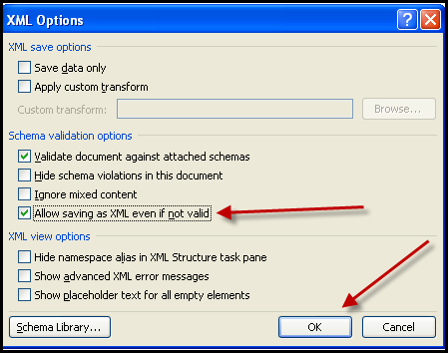

Document Tagging Example
In this section, we will take a sample document and tag a few elements with the StratML schema.
- Open the document in Word.
- Follow the steps given above to attach the schema.
- Select the complete text of the document and click on StrategicPlan from the bottom portion of the XML Structure panel.
- Word shows the following dialog box. Click on Apply to Entire Document.

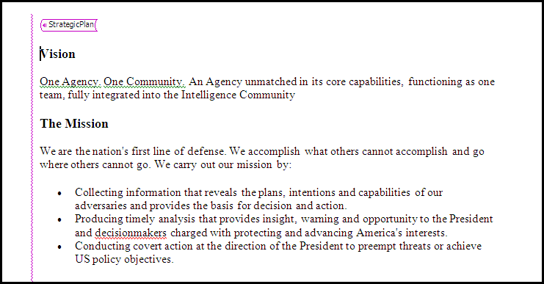

- Now apply StrategicPlanCore tag to the text till the end as shown below.

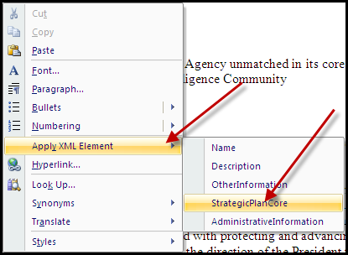

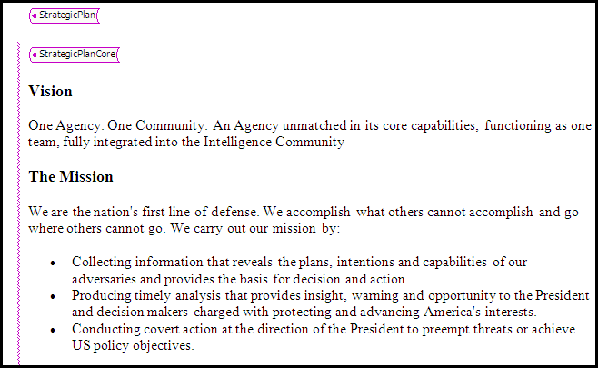

- Similarly, apply the Vision and Identifier tags to the relevant portions.

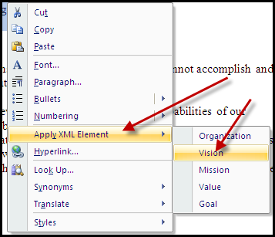

- For tagging specific elements, such as Identifier or Description, select the text to be tagged. Right click and select “Apply XML Element”, as shown below. The selected element will be applied to the selected text.
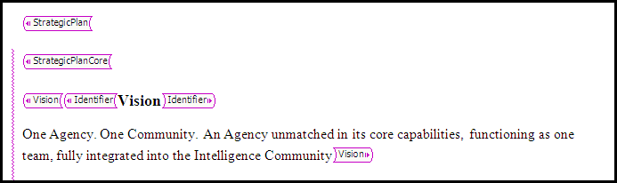

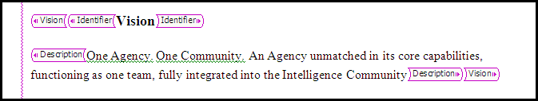

- The next Identifier is tagged similarly as shown below, and so on till the end of the document.

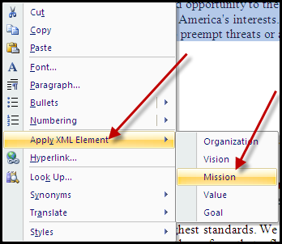

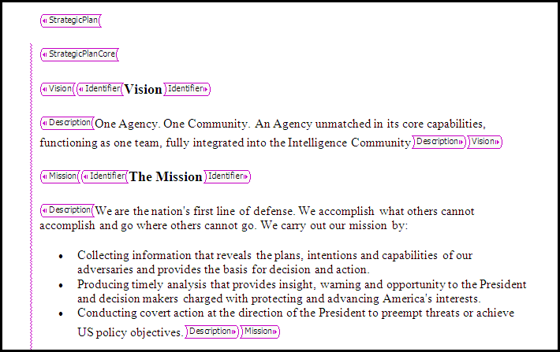

Contact Information
For questions related to StratML schema and initiative, please go to http://www.xml.gov/stratml/.
If you have any questions about tagging strategy documents with Microsoft Word or about this guide, please contact Ictect, Inc. The contact information is as-follows:
Ictect, Inc.
2320 Renaissance Blvd #226
Sturtevant, WI 53177
Ph: 262-898-7568
Email: support@ictect.com
Web: http://www.ictect.com

